CyberTAN Router Automatic Test Equipment (CyberRouterATE)
Application Design Document

Release v1.2
Last modified at: Friday, Feb 15, 2019

This document contains confidential proprietary information and is the property of CyberTAN Technology Inc.. The contents of this document may not be disclosed to any unauthorized person without the written consent of CyberTAN.

1. Introduction 1
1.1 Document revision history 1
1.2 Purpose 2
1.3 System overview 2
1.4 Software requirement 3
1.5 Equipments list 3
2. Implementation 4
2.1 Connection between PC and instruments 4
2.2 Connection between PC and DUT 4
2.3 Configuration profile 5
2.4 Graphical user interface design 7
2.5 Project tree 10
2.6 Report in Excel 11
3. Test cases 14
3.1 RvR Test 14
3.2 TBD 14
3.3 TBD 15
4. Conclusion 16
5. Further development 17
Appendix A: Instrument software API 18

- Introduction
In this document describes an automatic test system – The CyberRouterATE stands for CyberTAN Automatic Test Equipment for Router series that is created by CyberTAN software team. The automatic application is developed in Microsoft Visual C# Express 2010, and data presentation is using Microsoft Excel 2010. The application runs on a computer with a friendly graphical user interface (GUI). Its main task is to perform the test according to RD test plan and control the instrument (Angilent ) in some test case. Besides, a raw data has been designed to store all testing results in Excel file or csv file and analysis on the data has been presented as well.

  - Document revision history
Revision | Date | Author | Status and Description
1.0 | 2016-08-17 | Jin Wang | Initial version.
1.1 | 2016-09-29 | Jin Wang | RvR+Turn table test item added

  - Purpose
The purpose of CyberRouterATE is to improve the work efficiency to fully evaluate the router series performance and function tests according to the RD DVT plan or SQA test plan. Since the test cases are quite repeatable, a CyberRouterATE application should increase the test quality and decrease the development time for each product. According to the purpose of CyberRouterATE, this document will introduce the software architecture and design processes which to help designer or maintainer understand the CyberRouterATE quickly.

  - System overview
The CyberRouterATE includes three layers, as the following Figure-1 shown. The CyberRouterATE application layer is the windows PC application called CyberRouterATE measurement application. It has a GUI interface acts a main control interface, which is used to connect the instrument by GPIB, RS232 or TCP/IP communication through middle layer. The middle layer includes instrument and .Net APIs, which focuses on instruments interactivity during application running state. The latest VISA driver layer that control hardware interfaces, such as GPIB, TCP/IP and UART interfaces. Usually we specific the hardware interfaces on design phase explicitly.

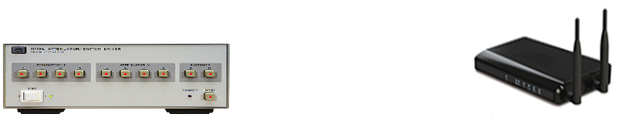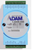
STA
CyberRouterATE Application
Instrument & .Net APIs
VISA/UART driver
Figure-1

  - Software requirement
The CyberRouterATE application is developed using C# language and stored the report data by Microsoft Excel or CSV file. The VISA instrument or UART control framework is software components, making CyberRouterATE application easier to enable and control Agilent or other equipments. So, you should be installed the following packages and libraries before developing the application.

- Microsoft C# 2010 Express http://www.visualstudio.com/downloads/download-visual-studio-vs
- Microsoft Office 2007
http://www.microsoft.com/zh-tw/download/office.aspx
- Microsoft .net framework v4.0+
http://www.microsoft.com/zh-tw/download/details.aspx?id=17718
- NI VISA 5.4+ library
http://www.ni.com/download/ni-visa-5.4/4230/en/
- NI GPIB driver
http://www.ni.com/white-paper/5326/en/

  - Equipments list
The Adam or Agilent equipment is test system which offers solutions for Router test case. It provides easy remote access by general purpose interface bus (GPIB), UART or local area network (LAN). There are brief descriptions as the following pictures:

- Agilent 11713A attenuator
The Agilent 11713A is a attenuation control system simulating the range attenuation for Wireless testing.
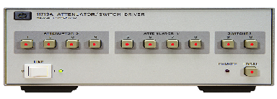
- Adam 4068 Relay
The Adam 4028 is a power relay controller providing the control ability of power on/off. It provides 8 channels on/off control or low-power switching application.
(The ADAM-4068 relay module is controlled remotely and store configuration data in EEPROM. The ADAM-4068 provides 4/8 channels, half being Form A and the rest being Form C. These modules are excellent for on/off control or low-power switching applications.)
- TBD
TBD.

- Implementation
The Figure-2 includes five modules. The part of CyberRouterATE control panel is the windows based GUI application. The main procedure of testing depends on the test items. The main functions of router testing are throughput, RvR and other router features. Some test items need to control instrument such as Attenuator, some don’t. During the recording period, the application displays debug information in real time and saves the results in the excel file (*.xls file) or csv file. When data collection is done, the report gives out the performance of test item by analyzing the results in the Excel/CSV.

Microsoft
Excel report
CyberRouterATE
Control Panel
Agilent/Adam instruments
Device Under Test
(DUT)
Configuration profiles
GPIB or Ethernet or UART
Phone Line
Figure-2

  - Connection between PC and instruments
The instrument API (Appendix A) handles each operation related with the Agilent/Adam instruments, including initializing the connection between the computer and the instrument and setting instrument value.
Building a connection between the PC and the instrument relies on socket communication, UART or GPIB. A static IP address, Comport or GPIB interface ID is assigned for the instrument, and use for remote control as the instrument user manual has defined. After executing a connect function provided by the C# library, the computer and the instrument have built the connection.

  - Connection between PC and DUT
The connection between PC and DUT are either RS232 or Ethernet. The UART class deals with every operation with the DUT when the interface is RS232. The socket class deals when the interface is Ethernet. The class initialize connection between the computer and the DUT, setting or getting the information to/from DUT. If RS232 is used, a COM port number is assigned for DUT, and the baud rate 9600/8N1 (depends on the device setting) is used for remote control.

  - Configuration profile
When the CyberRouterATE begins to run, it loads the configuration profile (*.xml file) to find the configurations for the different project settings. Here (Table-1) is the content listed in the configuration profile.

<?xml version="1.0" encoding="utf-8"?>
<!--DO NOT MODIFY THIS FILE. This file was generated by RvR Test program.-->
<CybertanATE Item="RvR Test">
<Attenuator>
<Band_2_4G>
<AttenuatorValue_2_4G>
<X1>1</X1>
<X2>2</X2>
<X3>4</X3>
<X4>4</X4>
<X5>10</X5>
<X6>20</X6>
<X7>40</X7>
<X8>40</X8>
</AttenuatorValue_2_4G>
<GPIB_Interface_2_4G>
<GPIB_Interface>0</GPIB_Interface>
</GPIB_Interface_2_4G>
<GPIB_Number_2_4G>
<GPIB_Number>4</GPIB_Number>
</GPIB_Number_2_4G>
<GPIB_IP_2_4G>
<IP_1>3</IP_1>
<IP_2>10</IP_2>
<IP_3>12</IP_3>
<IP_4>28</IP_4>
</GPIB_IP_2_4G>
</Band_2_4G>
<Band_5G>
<AttenuatorValue_5G>
<X1>1</X1>
<X2>2</X2>
<X3>4</X3>
<X4>4</X4>
<X5>10</X5>
<X6>20</X6>
<X7>40</X7>
<X8>40</X8>
</AttenuatorValue_5G>
<GPIB_Interface_5G>
<GPIB_Interface>0</GPIB_Interface>
</GPIB_Interface_5G>
<GPIB_Number_5G>
<GPIB_Number>0</GPIB_Number>
</GPIB_Number_5G>
<GPIB_IP_5G />
</Band_5G>
</Attenuator>
<FunctionTest>
<Model>
<Name>0</Name>
<SN>1234567890</SN>
<SWVer>1.0</SWVer>
<HWVer>1.0</HWVer>
</Model>
<Router>
<Username>admin</Username>
<Password>admin</Password>
<IP>192.168.1.1</IP>
</Router>
<Client>
<IPaddr_2_4G>192.168.1.100</IPaddr_2_4G>
<IPaddr_5G>192.168.1.101</IPaddr_5G>
</Client>
<Chariot>
<File>C:\Program Files (x86)\Ixia\IxChariot\IxChariot.exe</File>
</Chariot>
</FunctionTest>
</CybertanATE>

Table-1

In the XML file above, <CyberRouterATE> element has an attribute (Item="RvR Test"). It used to identify which XML file can be loaded for this test case “RvR Test”.
In the <Attenuator> part are the related to instrument default settings, it contains the IP address or GPIB interface ID. Usually, these settings are mapped in each instrument UI.
In the <FunctionTest> part provides some test parameters. The program reads these parameters to identity the chariot folder and DUT IP address or other settings for main function test.

  - Graphical user interface design
Two threads are used for Graphical User Interface (GUI), the main thread deals with all display operations, while the worker thread handles all the measurements on the DUT. They communicate with each other through message passing. The main thread makes the worker thread start or stop testing, while the worker thread does the real test procedure and feedbacks both the results and current progress to the main thread.
The GUI layout will spread two sections to describe the controller function, one that describes the implementation of main UI layout, test condition setting and instrument control panel, another section that describes the implementation of functionality test layout.
The section of main UI, test condition setting and instrument control panel see Figure-3. We take the RvR GUI for an example. Some test items may have different control panel. The Figure-3 also shows items number in red words which to describe the functionality by item number.
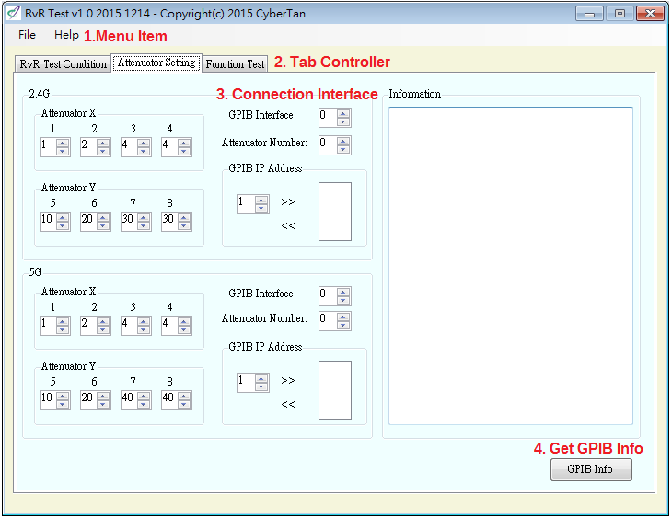
Figure-3

- Menu item: CyberATE router series provides two menu items for user to operate the configuration file saving or reading and application help document viewing.
- Tab controller: In the case, it provides three tab pages for operation. The “Attenuator” tab pages are using for instrument default control and connection. The
“Test Condition” tab page is used for configure the Router test condition. The “Function Test” tab page is using for configure the settings of test case. Next section will descript them in details.
- Connection interface: Each instrument has one communication interface which means you must fill the IP address or GPIB ID in this field.
- Get GPIB Info: Get the information of GPIB connecting to the PC now.

The UI of test condition function test control panel as the following Figure-4:
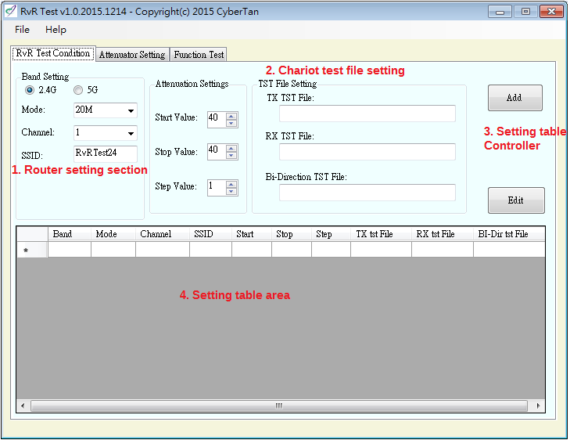
Figure-4

- Router setting section: This section used to configure the router, such as 2.4G or 5G, band mode, Channel, SSID, etc.
- Chariot test file setting: The section configure the chariot test file which ended with “.tst”. Use the chariot GUI to set the test condition and saved as tst file.
- Setting table section: Provide “Add” and “Edit” controller for setting table manager. “Add” button will add the setting to the setting table. Use “Edit” button to delete the unneeded setting column.
- Setting table area: Record the test condition. The test will go through all the setting in the setting table area from the top to the bottom. If the chariot test file include tx/rx/bi-direction, the flow will run through one by one.

The UI of function test control panel as the following Figure-5:
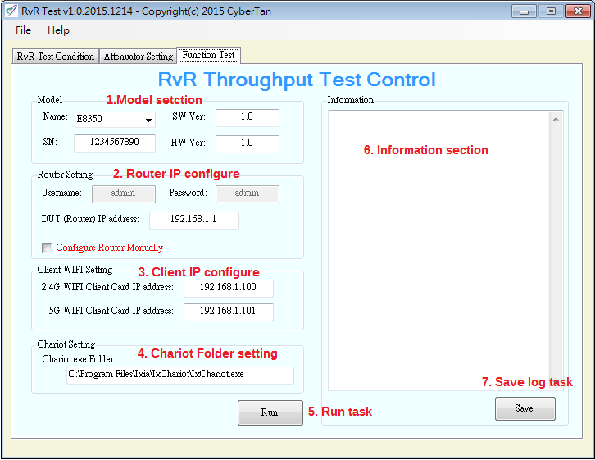
Figure-5

- Model section: There are four edit boxes for users to type in the information of different test cases. The information is used to make a excel file name and also saved it in excel.
- Router IP configure: Configure the route IP address. The router is usually configured by ether-net interface, so this sets ether-net IP address of router connecting to the PC.
- Client IP Configure: The function will test chariot data of the router, so the setting provides the client card ip address running the endpoint.
- Chariot folder setting : The test uses the Chariot console program that names “runtst.exe”, which locates in the same folder of “Chariot.exe”. This setting locates the program “chariot.exe” folder.
- Run task: The CyberATE uses button to Run or Stop program thread. The button displays “Stop” when program thread is running; otherwise, the button displays “Run”. The program thread can be interrupted by the manual with Stop button clicked.
- Information section: When running the test case, the results are shown in the Information window.
- Save log task: The “Save” button is used to save the content in the “information” window.

  - Project tree
This section describes the project tree of CyberRouterATE application. See Figure-6 below:

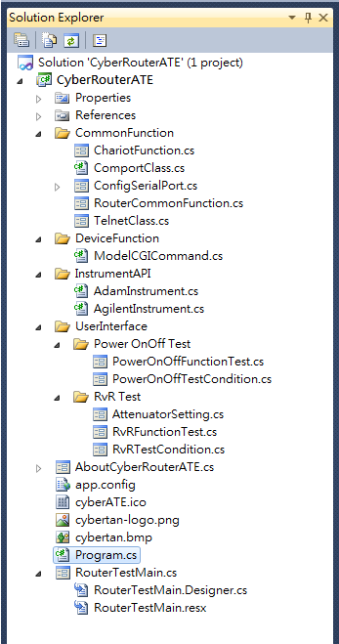
Figure-6

- CommonFunction folder: Stores Common function and variable, such as Excel save, close, create subfolder , set text on information textbox, telnet, comport function, csv function etc.
- DeviceFunction folder: Stores related device function. Each Device has it’s own file. The name of function is similar, such as Reset, PreConfigure.
- InstrumentAPI folder: Stores the related of instrument control APIs.
- UserInterface folder: Stores all of main test item functions, which includes both implementation source code and GUI layout in project subfolder.
- RouterTestMain.cs file: It is a CyberXdslATE program entry point and main GUI.
- AboutCyberRouterATE.cs file: This file includes two parts which includes the description of CyberRouterATE application and GUI designer.

  - Report in Excel
The CyberRouterATE stores and formats all the raw data into Excel or csv file. Although we have not used SQL to store and represent the data but this is a very simple and pretty way. The only thing, designer needs to re-implement and customize the layout of Excel cells or csv file depending on different test case or project. The example report for RvR represents in Figure-7. The Excel File includes the file name/test name and the test data.
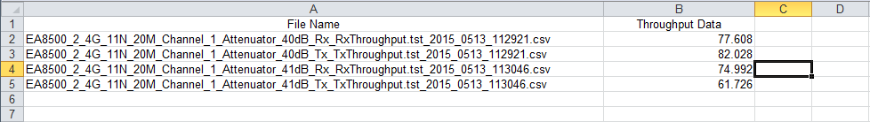
Figure-7

- Test cases
  - RvR Test
Purpose of test:
The purpose of this test case is to provide a test method to simulate the range atteunation. The test uses the IxChariot to test the throughtput and Agilent 11713A for attenuation control.
Test procedure/flow:
- Read test condition and initial the instrument.
- Configure the device with 2.4G/5G, mode, bandwidth, SSID. If user choose manually configure the DUT, skip this step.
- Configure attenuation to desired value.
- Run Chariot Test.
- Repeat step 3 to 4 till the all the attenuation test finish.
- Repeat step 2 to 5 for the next test condition.
- Write the file name and throughtput data to csv file.

Environment setup (Figure-8):
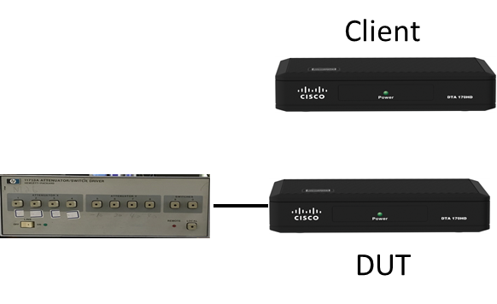
Figure-8

  - Power On/Off Test
Purpose of test:
The purpose of the test case is to test the device or adapter with power on and power off for a mount of times. When the device on , the CyberRouterATE support some ways to check the device work properly.
Test procedure/flow:
- Read test condition and initial the instrument.
- Count the maximum power on/off time and adam 4068 data.
- Create csv file for each test condition.
- Power off relay for maximum time. Then power on.
- Run each test condition action till maximum time up.
- Save the test result to csv file.
- Repeat step 3 to 6 for needed test times.
- Write the statistics data to each csv file.

Environment setup (Figure-9):
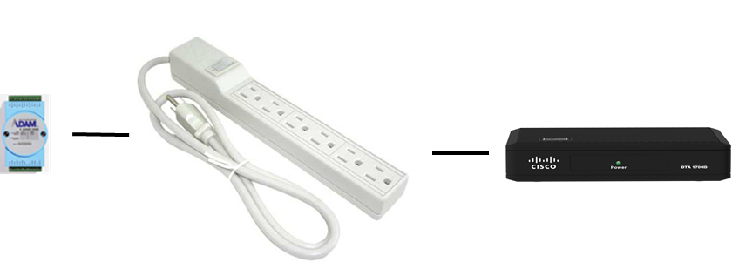

Figure-9
  - RvR +Turn table Test
Purpose of test:
The purpose of this test case is to provide a perfomance test with different angle and range attenuation. The test uses the IxChariot to test the throughtput, raspberry for controlling turn table angle and Agilent 11713A for attenuation control.
Test procedure/flow:
- Read test condition and initial the instrument.
- Configure the turn table to the desired angle.
- Configure the device with 2.4G/5G, mode, bandwidth, SSID. If user choose manually configure the DUT, skip this step.
- Configure attenuation to desired value.
- Run Chariot Test.
- Write data to csv file.
- Repeat step 4 to 6 till the all the attenuation test finish.
- Repeat step 3 to 6 for the next test condition.
- Repeat step 2 to 6 for all the setting angle.

Environment setup:

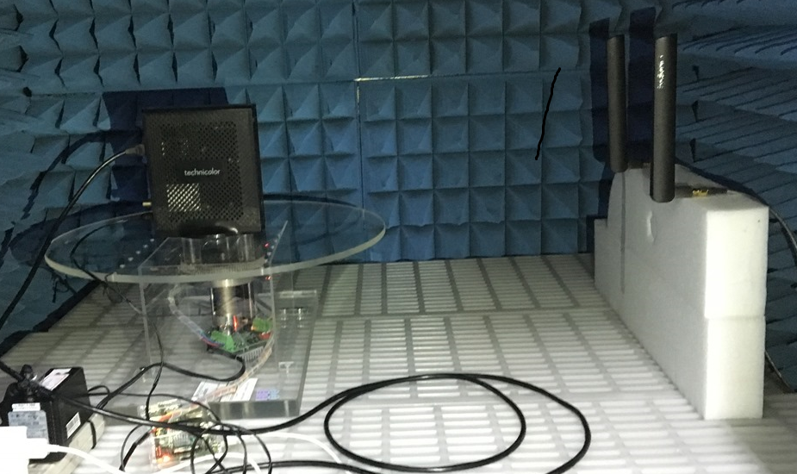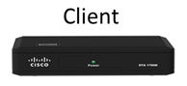

  - Chamber Performance Test
Purpose of test:
The purpose of this test case is to provide a performance test with different Wifi Band/ Channel/ Mode/ Bandwidth/ Security Combination. The test controls the web GUI of DUTs and uses the IxChariot to test the throughput, then record the average throughput value into report.
Test procedure/flow:
- Check parameter(including valid input value and file existence).

- Initial all the test condition into array.(Final report test condition/Dut Setting/Dut web Gui command sequence)
- Create Main Folder and new a thread to run main test flow.
- Read all columns parameter in DUT Setting Row 1 (DUT 1) and create sub folder base on the Model Name, then initial report excel file.
- Check all parameter of DUT 1 and Read Gui script into array.
- Update Web Gui Command depends on Band/Mode/BandWidth/Security
- Run Final Test Condition item 1 that was selected.
- Start to Run Web GUI Command sequence one by one base on the final test condition items 1.
- Connect to Remote Server and connect Wifi Client card to DUT(AP).
- Ping Client Card IP.
- Run IxChariot Tx tst file/ Rx tst file/Bi tst file and write the value to excel report.
- Repeat step 6 to 11 till the all the test condition selected test finish.
- Repeat step 4 to 12 till the all DUTs test finish
- End

Environment setup:
TBD

  - Throughput Test
Purpose of test:
The purpose of this test case is to provide a performance test with X5/X8 code of different Wifi Band/ Channel/ Mode/ Bandwidth/ Security Combination. The test controls the web GUI of DUTs and uses the IxChariot to test the throughput, then record the average throughput value into report..
Test procedure/flow:
- TBD

Environment setup:
TBD

  - TBD
Purpose of test:
TBS.
Test procedure/flow:
- TBD

Environment setup:
TBD

- Conclusion
In the beginning CyberRouterATE application, it loads the configuration settings and then fills the default values in each UI field. User can configure these default values according to test specification. The application displays debug information in real time and saves the results in the Excel file or csv file. When test is done or stop by manual, the report will be closed and stop the test automatically.
With this automatic application, it becomes quite convenient to repeat and long time the measurements for different products. Under control of the computer, the attenuation, power on/off or other test item is set, and no manual labor is wasted after the Start button has been clicked. So the CyberRouterATE application increases the measurement quality and decreases the development time a lot.
Besides, all these test cases are configurable simply by modifying the UI fields. The user can run a full test case with different test mode. But when testing manually in practice, one selects a limited test mode and range due to the work load. With an automatic application, one can test more modes than manually to find out problems. Especially during the development phase of a product with optimal performance, software and hardware is often updated. The application helps to find the performance difference after any change much faster than if done manually.
Finally, although the CyberRouterATE application can be completed many cases, it needs to re-design the application if a new test case activity. Developers also need to develop new test items refer to the new RD/QA test plan.
- Further development
Currently the test cases is derived from QA router test plan, but there are many test items of QA/RD requirement unfinished. Developers need to work on these test items to construct a full test system for Wi-Fi router system.

Appendix A: Instrument software API
Instrument | Function Name | Note
Agilent 11713A | preset | This function performs PRESET action.
 | configureAttenuator | This function configures attenuator.
Adam 4068 | Interface/Setting | RS232 , 9600/8N1
 | GetRelayStatus | This function gets the value of digital I/O channel
 | GetFirmwareVersion | This function reads the firmware version.
 | TurnOffRelay | This function turn off the power.
 | TurnOnRelay | This function turn on the power.
 | GetModuleName | This function reads the name of the module.

